Daniel
Understanding God’s Prophetic Timeline
September 2012
Good News Bible Studies
Prepared by Mike Southwick

Disturbed By A Dream
Daniel 2:1-49

“Blessed be the name of God forever and ever to whom belongs wisdom and might. He changes times and seasons; He removes kings and sets up kings, He gives wisdom to the wise and knowledge to those who have understanding; He reveals deep and hidden things; He knows what is in the darkness and the light dwells with Him” (Daniel 2:20-22, ESV)

A Taste of Divine Insomnia (Daniel 2:1-13)

- “Now in the second year of the reign of Nebuchadnezzar, Nebuchadnezzar had dreams; and his spirit was troubled and his sleep left him” (Daniel 2:1)

- It appears based on the plurality of the word “dreams” that the king could have been disturbed by the same recurring dream or least a series of dreams that were of a similar nature.

- We don’t know how long he had been troubled by these dreams but we at least know we are now into the second year of his reign.

- The dream apparently bothered or disturbed the king quite a bit:

- His spirit appeared ___________ which would probably mean he was anxious and concerned about its meaning.

- The king even appeared to _______ sleep over the dream and it no doubt at the time must have had a profound impact on the king; perhaps some deep spiritual, physical meaning that either affected the king personally or it involved his entire kingdom – or perhaps both as we will see.

- The king is so troubled that he calls together his wise men and close advisors
- “Then the king gave orders to call in the magicians, the conjurers, the sorcerers and the Chaldeans to tell the king his dreams. So they came in and stood before the king” (Daniel 2:2)

- The king called together his advisors:

- Magicians/Enchanters, were men who practiced the occult

- Sorcerers and Conjurers, were those who cast spells or practice witchcraft

- The Chaldeans were a “priestly” class of men who among many things were known as Astrologers and they primarily studied the stars and attempted to predict the future by them.

- The king wanted to know the meaning of the dream that was troubling him so this would have been the group of people that he would most rely on for this.

- We will see that these men will fail at this most important task because their foundation and basis for truth was built on complete falsehood and guess work.

- The dream itself as we will see; was given to King Nebuchadnezzar by the Lord not as much for the king’s benefit but to lay out a prophetic course of events that describe the future of His people and His future Kingdom that is yet to come.

- “The king said to them, I had a dream and my spirit is anxious to understand the dream. Then the Chaldeans spoke to the king in Aramaic: O King live forever! Tell the dream to your servants and we will declare the interpretation. The king replied to the Chaldeans, the command from me is firm, if you do not make known to me to dream and its interpretation, you will be torn limb from limb and your houses will be made a rubbish heap” (Daniel 2:3-5)

- The assumption by the king is that this is what these guys do so he assumes this should be an easy task – he wants to know the ______________of the dream.

- The king adds an interesting twist by requiring that they first ________ the dream itself and then gives its _________. We are not told why he asks for what the wise men will describe as impossible, but he is clear on his expectation and request!
- “The Chaldeans answered the king and said; there is not a man on earth who could declare the matter for the king, inasmuch as no great king or ruler has ever asked anything like this from any magician, conjurer, or Chaldean. Moreover, the thing which the king demands is difficult, and there is no one else who could declare it to the king except gods, whose dwelling place is not with mortal flesh” (Daniel 2:10-11)

- Clearly the king’s request was _______________ and the Chaldeans (Babylonian priests and astrologers) were well aware of their own personal ______________.

- They even admit; “there is not a man on earth who could declare that matter for the king”.

- The Chaldeans boasted of being able to read and understand the stars, and by them they would attempt to understand and predict the future, although even they knew they were never 100% correct and so did the king.

- In the end they were _________, mere ___________ and they were about to be exposed! The gods they served were also frauds! The devil who was their master is a fraud.

- The Chaldeans do recognize that the gift or ability to fulfill the king’s request rested in the world beyond the human realm and it could only be found by consulting the “gods”. This was something that was above their pay grade.

- “Because of this the king became indignant and very furious and gave orders to destroy all the wise men of Babylon. So the decree went forth that the wise men should be slain; and they looked for Daniel and his friends to kill them” (Daniel 2:12-13)

- The king wanted an __________ interpretation of his dream and he just exposed the falsehood of the Chaldeans so his anger is roused against them.

- By order of the king - he calls for all the wise men of Babylon to be _______

- Since Daniel and his companions were in training to become advisors to the king, they were lumped into this group of “wise men” and they too were eligible to be killed even though they were innocent of any wrong doing.
An opportunity for Daniel to Intercede (Daniel 2:14-18)

- “Then Daniel replied with discretion and discernment to Arioch, the captain of the king’s bodyguard, who had gone forth to slay the wise men of Babylon; he said to Arioch, the king’s commander, for what reason is the decree from the king so urgent? Then Arioch informed Daniel of the matter” (Daniel 2:14-15)

- Arioch is identified here as the chief body guard and was probably the chief executioner for the king since he was put in charge of killing the wise men.

- Daniel apparently had direct __________ to Arioch and was able to use that relationship to also gain trust to allow him to have an audience with the king.

- “So Daniel went in and requested of the king that he would give him time, in order that he might declare the interpretation to the king” (Daniel 2:16)

- It is interesting to note here that Daniel was apparently ________ to approach the king even in the midst of the king’s frustration with his advisors and wise men.

- Most conclude that Daniel’s __________ carried a lot of weight with the king and thus allowed him an opportunity that the others Chaldeans and wise men had lost.

- What we really ought to see here is; The Lord was clearly orchestrating these events so it’s not like the king had much choice in the matter anyway!

- “Then Daniel went to the house and informed his friends, Hananiah, Mishael, and Azariah, about the matter, so that they might request compassion from the God of heaven, concerning this mystery, so that Daniel and his friends would not be destroyed with the rest of the wise men of Babylon” (Daniel 2:17-18)

- Daniel and his companions gathered for prayer and made two requests if the Lord:

- That the Lord would have _______ and ___________ concerning this mystery

- That their lives would be __________

- Their prayers were about to be answered even _________ what they prayed
The Provision of Divine Insight (Daniel 2:19-30)

- “Then the mystery was revealed to Daniel in a night vision. Then Daniel blessed the God of heaven” (Daniel 2:19)

- This was a direct answer to the _________ of Daniel and his companions as they prayed that the Lord would show mercy and compassion upon them. This mercy and compassion comes in the answer to the second part of their prayer – the actual sparing of their lives from the kings wrath because Daniel will be able to tell the king his dream and its interpretation.

- The Lord, by supernatural _________________, will reveal the “mystery” (the king’s dream and the interpretation) directly to Daniel and did so that very night.

- “Daniel answered and said; blessed be the name of God forever and ever, to whom belongs wisdom and might. He changes times and seasons; he removes kings and sets up kings, he gives wisdom to the wise, and knowledge to those who have understanding; he reveals deep and hidden things; he knows what is in the darkness, and the light dwells with him. To you O God of my fathers, I give thanks and praise, for you have given me wisdom and might and have now made known to me what we asked of you, for you have made known to us the king’s matter” (Daniel 2:20-23)

- In Daniel’s response to the Lord’s answer to their prayer he offers praise to God

- Daniel acknowledges several things about the Lord:

- All _______ (He knows the beginning from the end) and ________ (whatever He determines He does) belong to Him.

- He ___________ times and seasons

- He _______ up kings and he __________ them

- He reveals deep and unknown things and the light dwells with Him or as the Apostle John writes; He is light and in Him is no darkness at all (I John 1:5-7)

- Daniel concludes his response to the Lord with _________ and _________
- “Therefore, Daniel went in to Arioch, whom the king had appointed to destroy the wise men of Babylon; he went and spoke to him as follows: do not destroy the wise men of Babylon! Take me into the king’s presence and I will declare the interpretation to the king. Then Arioch hurriedly brought Daniel into the king’s presence and spoke to him as follows; I have found a man among the exiles from Judah who can make the interpretation to the king” (Daniel 2:24-25)

- This was a _______ move my Daniel but his _____ was in God not in anyone else

- Arioch appears to take false ______ for finding an interpreter for the kings dream

- “The king said to Daniel, whose name was Belteshazzar, Are you able to make known to me the dream which I have seen and its interpretation? Daniel answered before the king and said; as for the mystery about which the king has inquired, neither wise men, conjurers, magicians, nor diviners are able to declare it to the king. However there is a God in heaven who reveals mysteries and He has made known to King Nebuchadnezzar what will take place in the latter days. This was your dream and the visions in your mind while on your bed” (Daniel 2:26-28)

- Daniel quickly points out the ___________ of the king’s advisors and wise men

- Daniel follows up with a masterpiece of an answer for he says; “However, there is a God in heaven who reveals mysteries and He has made known to King Nebuchadnezzar what will take place in the latter days”

- “As for you, O king, while on your bed your thoughts turned to what would take place in the future; and He who reveals mysteries has made known to you what will take place. But as for me, this mystery has not been revealed to me for any wisdom residing in me more than in any other living man, but for the purpose of making the interpretation known to the king, and that you may understand the thoughts of your mind” (Daniel 2:29-30)

- Daniel points out to the king that he has had the fortune of being told (through his dream) what will take place in not just the immediate future (The Times of the Gentiles – Luke 21:24) but the ________ future of mankind.

- Daniel takes no ______ for interpreting the dream and accepts no assigned _____
The Prophetic Interpretation of the King’s Dream (Daniel 2:31-45)

- Daniel ________ the dream for King Nebuchadnezzar (Daniel 2:31-35)

- “You, O king, were looking and behold, there was a single great statue, that statue, which was large and of extraordinary splendor, was standing in front of you, and its appearance was awesome” (Daniel 2:31)

- As Daniel describes the dream he draws attention to this “great statue” which was __________ in size.

- The statue itself was “frightening in appearance” (ESV) and may have had Nebuchadnezzar pretty shook up. The KJV describes its form as “________”.

- “The head of the statue was made of fine gold, its breast and its arms of silver, its belly and its thighs of bronze, its legs of iron, its feet partly of iron and partly of clay.” (Daniel 2:32-33)

- It’s head was made of _______

- It’s breast and arms were made of ________

- It’s belly and thighs were made of _________

- Its legs were made of _____ and feet were a mixture of _____ and ______

- “You continued looking until a stone was cut out without hands, and it struck the statue on its feet of iron and clay and crushed them. Then the iron, the clay, the bronze, the silver and the gold were crushed all at the same time and became like chaff from the summer threshing floors; and the wind carried them away so that not a trace of them was found. But the stone that struck the statue became a great mountain and filled the whole earth” (Daniel 2:34-35)

- The stone that was cut without hands was not a _______ of the statue

- The stone actually ______ the statue, ______ it and _____ or _____ the earth

- Daniel ____________ the dream for King Nebuchadnezzar (Daniel 2:39-45)

- “This was the dream; now we will tell its interpretation before the king. You, O king, are the king of kings, to whom the God of heaven has given the kingdom, the power, the strength, and the glory; and wherever the sons of men dwell, or the beasts of the field, or the birds of the sky, He has given them into your hand and has caused you to rule over them all. You are the head of gold” (Daniel 2:36-38)

- Daniel begins the interpretation by describing the statue from the head down to the toes and he identifies the head of the statue as __________________.

- Some conclude that it is possible that the head of gold represent the entirety of the Babylonian Empire/kingdom and not just the king.

- The head is made of gold which may have had some significant meaning as it appears that there is an intentional deterioration or lessening of value in the metals as you move from the head down to the feet. Gold is considered to be the most valuable and finest of all the metals.

- Daniel makes it clear that King Nebuchadnezzar was placed as ruler over a kingdom (in this case the Babylonian Empire) and the right and power to rule over this kingdom was given to him by the ____________________.

- Daniel makes reference to King Nebuchadnezzar as being the ____________, which is something that Ezekiel (another prophet who ministered in Babylon during the exile) also made reference to in his prophetic writings during the days in which Nebuchadnezzar attacked the coastal city of Tyre and its territories. (Ezekiel 26:7)

- If you recall Daniel had stated earlier that it was God who _______ up kings and ___________ them. (Daniel 2:20-21)

- At the time of Nebuchadnezzar’s reign, the kingdom of Babylonian was considered a vast _____________ empire and although Nebuchadnezzar may have been its ruler; the fact remained that the king was merely fulfilling God’s plan for mankind. Daniel made this point very clear to the king!

The Babylonian Empire

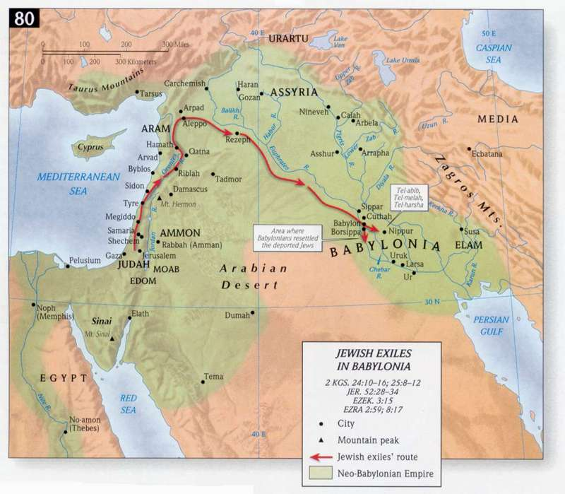

The Land of Israel and Judah

- “After you there will arise another kingdom inferior to you” (Daniel 2:39a)

- The second part of the statue is identified as the “breast and arms” in Daniel 2:32a, and the metal associated with this portion of the statue was silver.

- Daniel doesn’t specify or identify who or what this part of the statue would represent as he does with the “head of gold”, but he does make reference that it is “__________ kingdom” which will arise after Nebuchadnezzar or after the Babylonian Empire itself.

- Daniel also tells the king that this “other kingdom” will be ________ in some way to the Babylonian kingdom.

- A good thing to point out here is the dream itself was _________ or in the _________ to Nebuchadnezzar so he may or may not have been able to draw a conclusion as to who or what this kingdom was.

- We have the benefit of history and most scholars conclude that the reference to this “another kingdom” that came after the Babylonian Empire would best fit the Medo-Persian Empire.

- The Medo-Persians conquered the Babylonians in 539 BC after several wars that brought the Babylonians under their submission.

- There is quite a bit of discussion as to what is meant by “inferior” in that the Persian Empire lasted 200 years (approx. 113 years longer than the Babylonian Empire) and occupied more territory than was conquered by King Nebuchadnezzar. It’s hard to draw a conclusion one way or the other but it could simply mean a kingdom not as great as the Babylonian Empire.

- The description for this portion of the statue; “its breast and its arms of silver”, are also an interesting topic of discussion as to its meaning. The best explanation I have been able to accept is that the two arms could represent the individual people groups (The Medes and The Persians) and the chest/breast would be the combined Persian Empire that ruled for nearly 200 years.

- What we know for sure is the ________ Empire does succeed the Babylonians
The Persian Empire

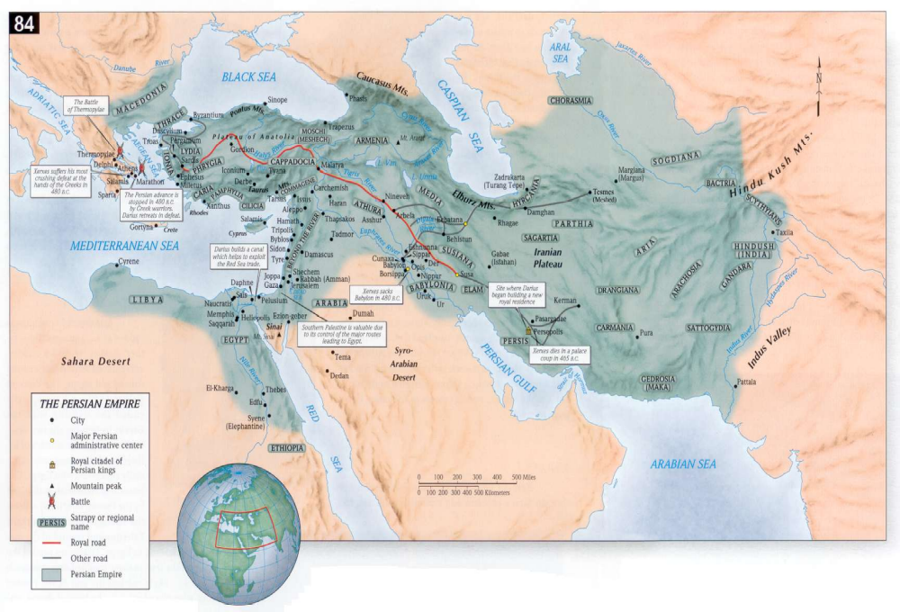

The Land of Israel and Judah

- “Then another third kingdom of bronze, which will rule over all the earth” (Daniel 2:39b)

- The third part of the statue is identified as the “belly and thighs” in Daniel 2:32b, and the metal associated with this portion of the statue was bronze.

- In the same way as the second kingdom, Daniel also doesn’t specify or identify who or what this part of the statue would represent as he does with the “head of gold”.

- This is “another third kingdom” which is apparently different than the second kingdom and this kingdom will ______ over all the ________.

- This was also ___________ or in the __________ to Nebuchadnezzar so he probably would not have been able to draw a conclusion as to who or what this kingdom was.

- Again we have the benefit of history and most scholars conclude that the reference to this “another third kingdom” that came after the Persian Empire would best fit the _________ Empire.

- History records for us that _____________ the Great conquered the Persian Empire between the years 334-330 BC.

- The Greek Empire conquered more territory than the Babylonians or the Persians. It spanned from Greece and all the way down into _________ and to the east as far as _________.

- The reference that this kingdom would “rule over all the earth” is interpreted by most to mean that during the Greek rule of a large portion of the known world was evidenced in its influence in a number of areas such as architecture, literature, language, arts, science, athletics, and major militarily achievements.

- There is no real solid explanation of the description in Daniel 2:32 where it describes this portion of the statue as “its belly and its thighs of bronze”, but we do know that history records that the Greek Empire does conquer the Persian Empire and they do rule the world at that time.

The Greek Empire

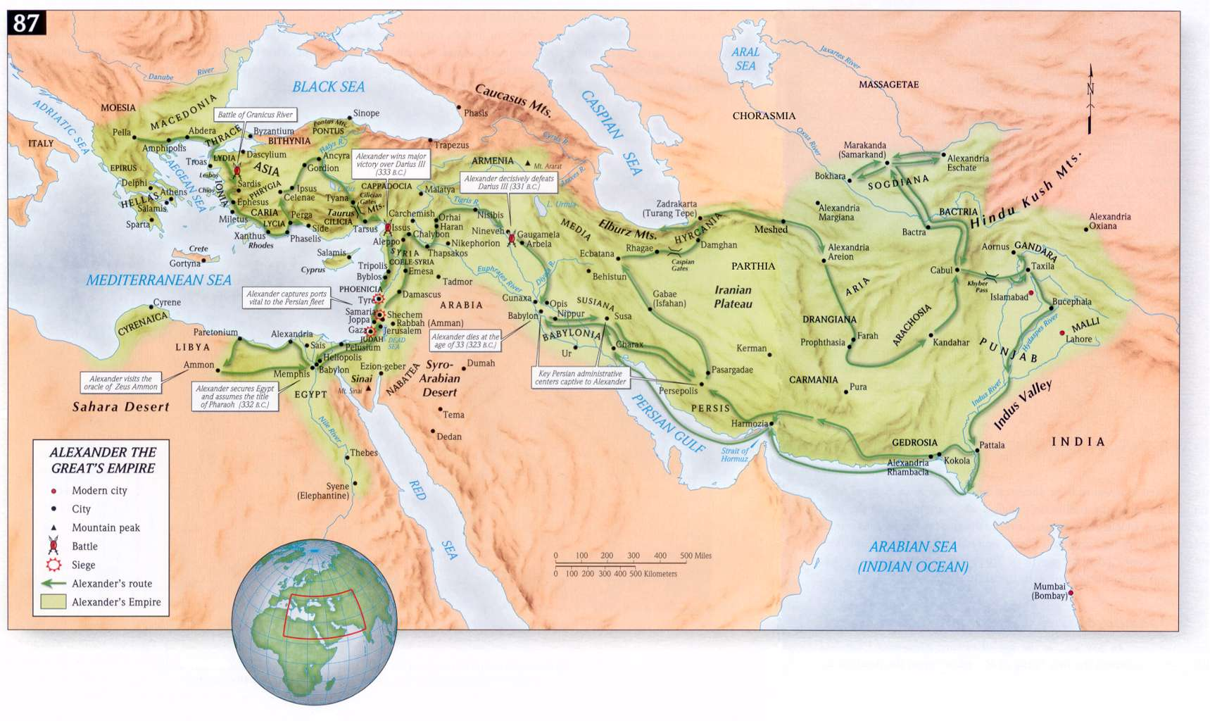

The Land of Israel and Judah

- “Then there will be a fourth kingdom as strong as iron; inasmuch as iron crushes and shatters all things, so. Like iron that breaks in pieces, it will crush and break all these in pieces. In that you saw the feet and toes, partly of potter’s clay, and partly of iron, it will be a divided kingdom; but it will have in it the toughness of iron, inasmuch as you saw mixed with common clay. As the toes of the feet were partly of iron and partly of pottery, so some of the kingdom will be strong and part of it will be brittle. And in that you saw the iron mixed with common clay, they will combine with one another in the seed of men; but they will not adhere to one another, even as iron does not combine with pottery” (Daniel 2:40-43)

- The fourth part of the statue is identified as the “legs and feet” in Daniel 2:33, and the metal associated with this portion of the statue was ______ as well as a non-metal identified as _______.

- In the same way as the third kingdom, Daniel also doesn’t specify or identify who or what this part of the statue would represent as he does with the “head of gold”.

- This “fourth kingdom” will be “strong as ____” and it will be a “_________ kingdom” and after it divides it seems to deteriorate in quality and form.

- This was also _________ or in the _________ to Nebuchadnezzar so he probably would not have been able to draw a conclusion about this kingdom.

- Once again we have the benefit of history and most scholars conclude that the reference to this “fourth kingdom” that came after the Greek Empire would best fit the ___________ Empire.

- The Romans conquered the Greeks in 63 BC and __________ the world until it ______ in A.D. 364 (Eastern Empire and Western Empire) and it “unofficial end” came about in A.D. 1453 but in many ways its culture and structure still continues to impact and influence the modern world. Some feel that this Empire will be revived during the Tribulation Period – more on that later.

- Some conclude that the Roman Empire had a gradual deterioration and weakening as it was so large and encompassed so many different cultures that it couldn’t retain its power and it simply couldn’t sustain itself.
The Roman Empire

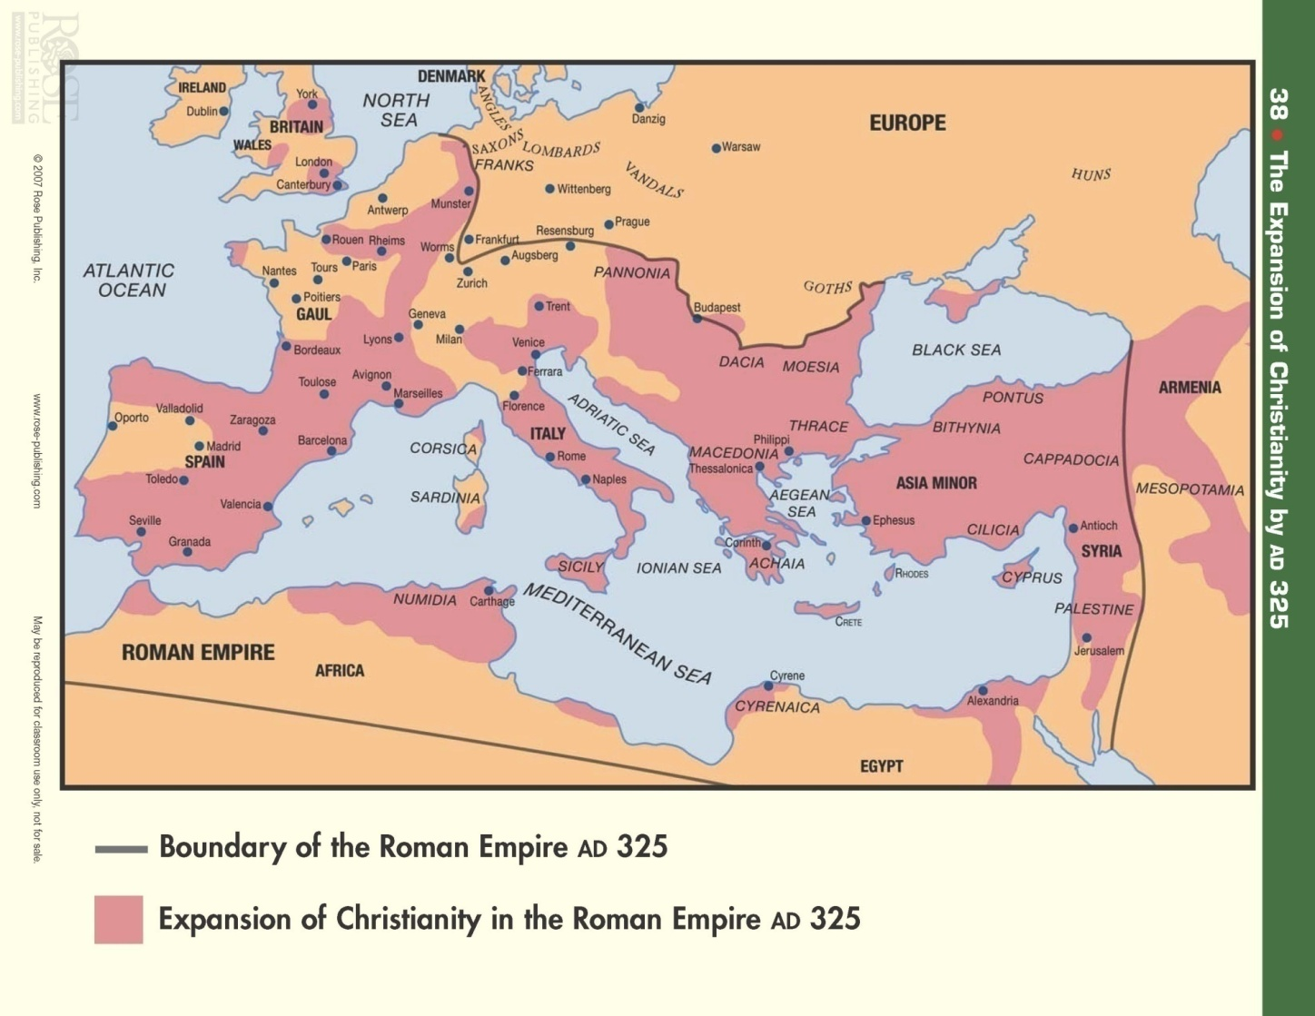

The Land of Israel and Judah

- “In the days of those kings the God of heaven will set up a kingdom which will never be destroyed, and that kingdom will not be left for another people; it will crush and put an end to all these kingdoms, but it will itself endure forever. Inasmuch as you saw a stone cut out of the mountain without hands and that it crushed the iron, the bronze, the clay, the silver and the gold, the great God has made known to the king what will take place in the future; so the dream is true and its interpretation is trustworthy” (Daniel 2:44-45)

- There will be a _____ kingdom that will be set up/established by the God of heaven and this kingdom will not be _________ and it will have no ______.

- This final kingdom according to Daniel 2:34-35 is not a part of the ______ and it does not have any connection to any ________ as did the statue.

- This final kingdom is described as a ___________ cut without _______ which will strike the statue in such a way that the statue (which represents all of the human kingdoms of the world; Babylon, Persian, Greek and Roman) will be destroyed and turned to _______. (Daniel 2:35, 45)

- The Scriptures often use the term “rock” to refer to Jesus Christ who is the promised Messiah. (Psalm 118:22, Isaiah 8:14, Isaiah 28:16, I Peter 2:6-8)

- In Daniel 2:35 we are told that the stone becomes a __________ and fills the whole _______; and the understanding here is that the four empires (Babylon, Persia, Greece and Rome) would rule over the people of Israel, and one day be destroyed not by human means but by the coming of the Messiah Jesus Christ.

- The traditional view is that this is the ________________ kingdom that was promised to Israel through King David (II Samuel 7:16).

- Some conclude, such as the Amillennialists that this kingdom was established at Christ’s first Advent (His birth) and that the ________ is that kingdom.

- The Premillenarians conclude that this kingdom that will be established by Christ on earth is yet in the _______ after His second coming. (Rev. 19:11-20)

- We know that the dream was ______ and the interpretation was __________!
The Final Kingdom

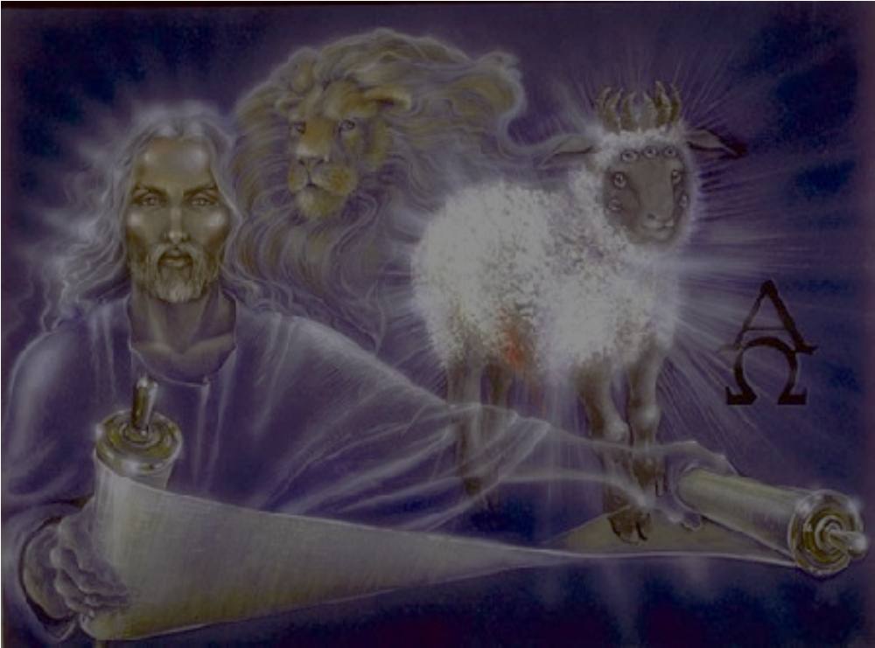

Revelation 5:1-14
Revelation 19-22

The Promotion of Daniel and His Companions (Daniel 2:46-49)

- “Then King Nebuchadnezzar fell on his face and did homage to Daniel, and gave orders to present to him an offering and fragrant incense. The king answered Daniel and said, surely your God is a God of gods and a Lord of kings and a revealer of mysteries, since you have been able to reveal this mystery” (Daniel 2:46-47)

- The king ________ Daniel for revealing the dream and its meaning by falling __________ (doing homage - To lay flat or cast oneself down in humility and reverence) at his feet and presenting him with an ___________.

- This would not have been the norm for a king to do to a subject of his kingdom let alone a captured foreigner such as Daniel.

- This type of behavior by the king; doing/paying homage and making an offering is customarily reserved behavior for the gods of Babylon.

- Nebuchadnezzar makes an interesting confession to Daniel; he confesses that Daniel’s God is ____________ than all of the gods of Babylon and his God is Lord over all the kings of the earth including Nebuchadnezzar himself.

- “Then the king promoted Daniel and gave him many great gifts, and he made him ruler over the whole province of Babylon and chief prefect over all the wise men of Babylon. And Daniel made request of the king, and he appointed Shadrach, Meshach, and Abed-Nego over the administration of the province of Babylon, while Daniel was at the king’s court” (Daniel 2:48-49)

- All of this resulted in Daniel receiving ________ from the king and a significant ____________. He is placed as a ruler/satrap over a local province and he was also put in charge over all the wise men of Babylon.

- The position that Daniel held probably allowed him to act as a _____________ between the king and the exiles brought from Judah (597-586 B.C.) to Babylon.

- Daniel doesn’t forget his three ___________ and is able to secure them a place of authority (probably some sort of judicial overseer) in the Babylonian government.

Concluding Remarks:

- The promotion of Daniel and his companions will be met with jealousy and contention from the other governmental leaders and wise men of Babylon, who no doubt resented the special privilege and honor showed to these four Jewish exiles. We will see that resentment expressed in Daniel chapter 3.

- The king, who was completely impressed with the God of Daniel and even confessed Him to be the God of gods, will allow pride to get the best of him and in chapter 3 we will see that he builds a large monument that he ironically makes from gold.

- The king will require everyone in Babylon to worship this image which causes Daniel and his companions to be put to the test by having to choose to either violate their commitment to the Lord and live or honor the Law of God and face potential death.

- The character of Daniel and his companions remains strong and they do not compromise their stand which results in them being thrown into the fiery furnace – a famous story that in some peoples mind has been relegated to a fairy tale but as we will see next week, it is completely true and real and it brings glory to God and causes King Nebuchadnezzar to once again express reverence and awe to the Lord God.

